# index.php

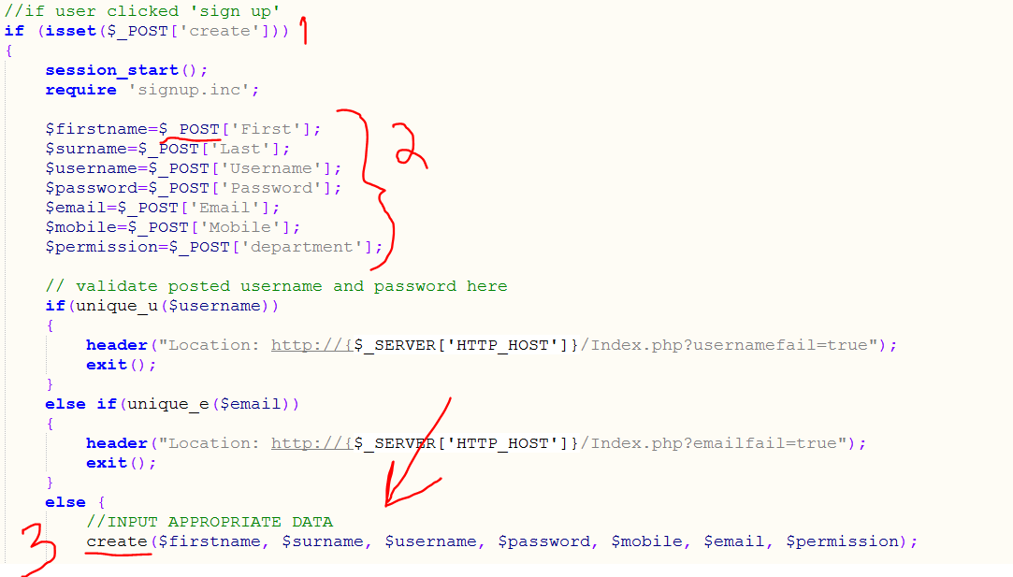

Step 1:

User fills out input fields with values and ‘posts’ form

Step 2:

User saves those values to PHP $ variables

Step 3:

User calls a PHP function…

# signup.inc

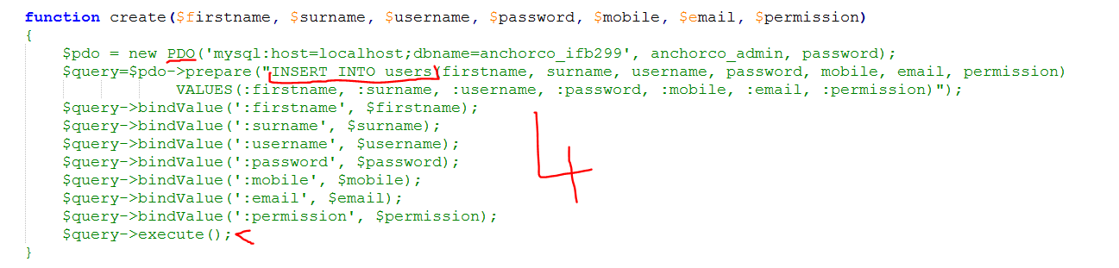

Step 4:

…To insert the values into a database table (e.g. ‘users’) using PDO and SQL queries.